Prismatoid
# Source: AI Source: Provided by: [Data Path: Persons Table -> ID Column: 1, Name_En Column: Motasem Essam] -> From: [ChatGPT] on [7/25/2026]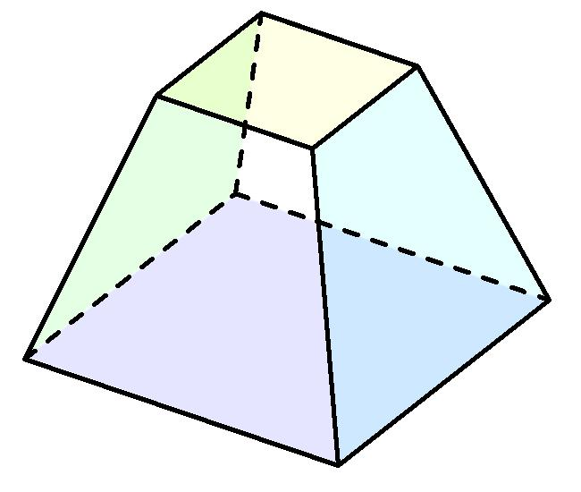

Definition
# Source: AI Source: Provided by: [Data Path: Persons Table -> ID Column: 1, Name_En Column: Motasem Essam] -> From: [ChatGPT] on [7/25/2026]
A Prismatoid is a polyhedron whose vertices all lie in two parallel planes. Its two parallel faces, called the bases, are polygons that may have different shapes and sizes. The remaining faces are triangular or trapezoidal polygons connecting the two bases.
Unlike a prism, a prismatoid does not require its two bases to be congruent or identical in shape.

Geometric Structure
# Source: AI Source: Provided by: [Data Path: Persons Table -> ID Column: 1, Name_En Column: Motasem Essam] -> From: [ChatGPT] on [7/25/2026]
A prismatoid consists of:
- Upper Base: A polygon lying in one of the two parallel planes.
- Lower Base: A polygon lying in the other parallel plane.
- Lateral Faces: Polygonal faces connecting the boundaries of the two bases. These are commonly triangles or trapezoids.
- Vertices: All vertices lie in one of the two parallel planes.
- Edges: Include the edges of both bases and the lateral connecting edges.

Types of Prismatoids
# Source: AI Source: Provided by: [Data Path: Persons Table -> ID Column: 1, Name_En Column: Motasem Essam] -> From: [ChatGPT] on [7/25/2026]
Prismatoids include several familiar polyhedral families:

Prisms
# Source: AI Source: Provided by: [Data Path: Persons Table -> ID Column: 1, Name_En Column: Motasem Essam] -> From: [ChatGPT] on [7/25/2026]
Two congruent, parallel polygonal bases connected by parallelograms.
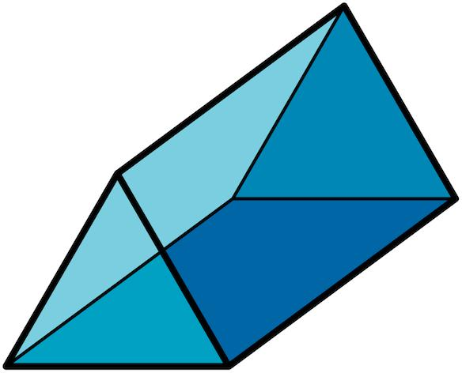

Pyramids
# Source: AI Source: Provided by: [Data Path: Persons Table -> ID Column: 1, Name_En Column: Motasem Essam] -> From: [ChatGPT] on [7/25/2026]
One polygonal base and an apex in the other parallel plane.
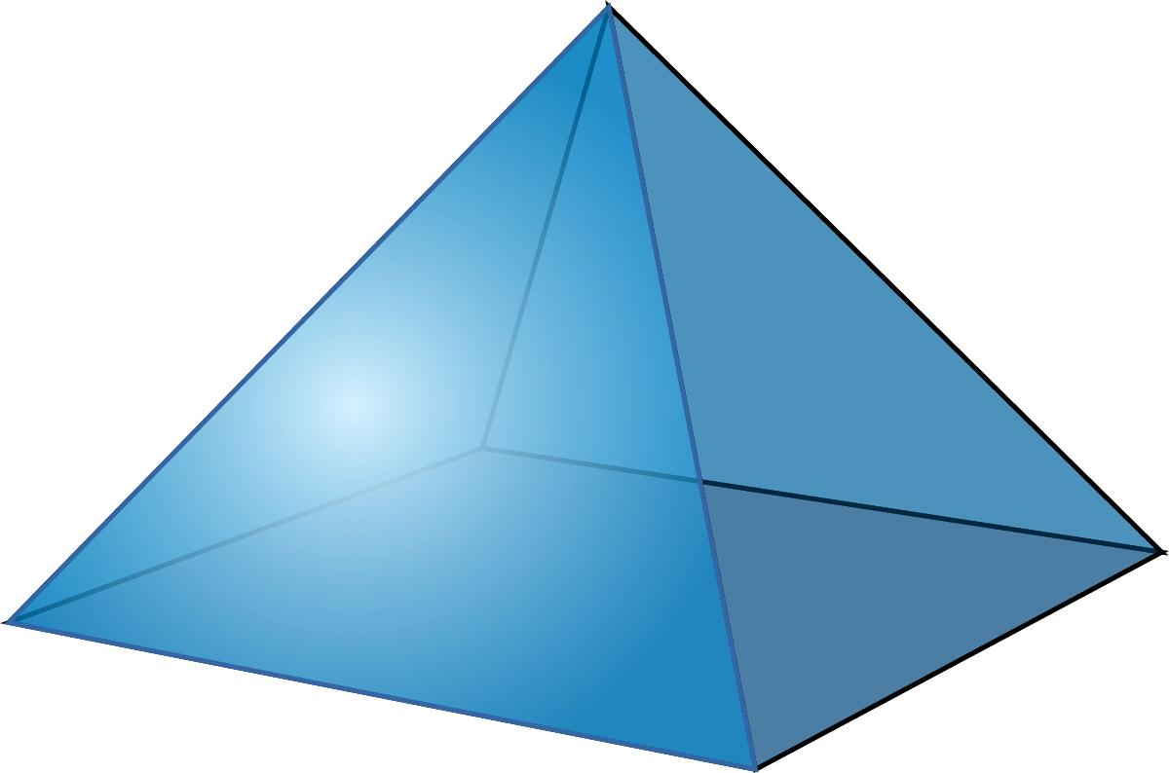

Pyramidal Frustums
# Source: AI Source: Provided by: [Data Path: Persons Table -> ID Column: 1, Name_En Column: Motasem Essam] -> From: [ChatGPT] on [7/25/2026]
Two parallel polygonal bases of different sizes, connected by trapezoidal faces.
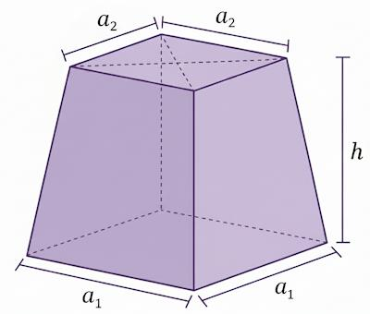

Antiprisms
# Source: AI Source: Provided by: [Data Path: Persons Table -> ID Column: 1, Name_En Column: Motasem Essam] -> From: [ChatGPT] on [7/25/2026]
Two congruent, parallel polygonal bases connected by alternating triangular faces.
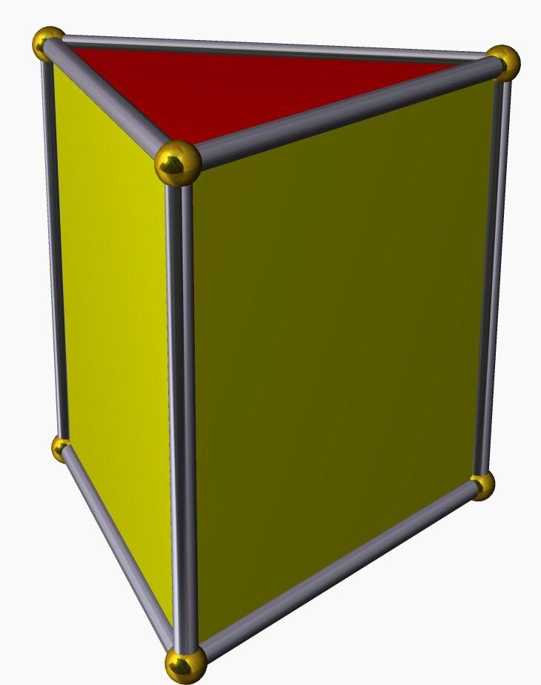

Wedges
# Source: AI Source: Provided by: [Data Path: Persons Table -> ID Column: 1, Name_En Column: Motasem Essam] -> From: [ChatGPT] on [7/25/2026]
Prismatoids with a triangular or narrow polygonal end opposite a larger base.
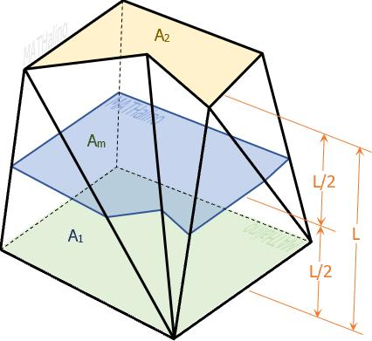

Cupolas
# Source: AI Source: Provided by: [Data Path: Persons Table -> ID Column: 1, Name_En Column: Motasem Essam] -> From: [ChatGPT] on [7/25/2026]
Solids with parallel polygonal bases of different side counts, connected by alternating triangles and rectangles.
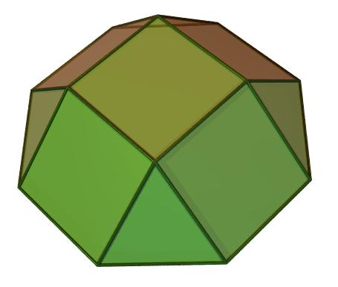

Mathematical Properties
# Source: AI Source: Provided by: [Data Path: Persons Table -> ID Column: 1, Name_En Column: Motasem Essam] -> From: [ChatGPT] on [7/25/2026]
A prismatoid does not have one fixed number of faces, edges, or vertices. These depend on the shapes and arrangements of its two bases.

Prismatoid Volume Formula
# Source: AI Source: Provided by: [Data Path: Persons Table -> ID Column: 1, Name_En Column: Motasem Essam] -> From: [ChatGPT] on [7/25/2026]
The volume is calculated using the prismoidal formula:
$$\boxed{V=\frac{h}{6}(A_{1}+4A_{m}+A_{2})}$$
Where:
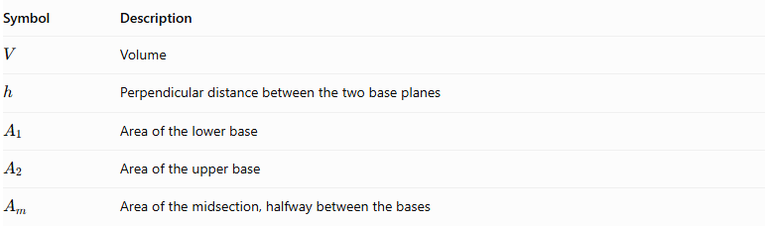
Symbol | Description
$$V$$ | Volume
$$h$$ | Perpendicular distance between the two base planes
$$A_{1}$$ | Area of the lower base
$$A_{2}$$ | Area of the upper base
$$A_{m}$$ | Area of the midsection, halfway between the bases

Euler's Polyhedron Formula
# Source: AI Source: Provided by: [Data Path: Persons Table -> ID Column: 1, Name_En Column: Motasem Essam] -> From: [ChatGPT] on [7/25/2026]
For a convex prismatoid:
$$V-E+F=2$$
Where:
- $V$ = Number of vertices.
- $E$ = Number of edges.
- $F$ = Number of faces.

Key Points
# Source: AI Source: Provided by: [Data Path: Persons Table -> ID Column: 1, Name_En Column: Motasem Essam] -> From: [ChatGPT] on [7/25/2026]
- All vertices lie in two parallel planes.
- The two bases may have different shapes and sizes.
- Lateral faces are generally triangles or trapezoids.
- The perpendicular distance between the base planes is called the altitude.
- Prisms, pyramids, pyramidal frustums, and antiprisms are examples of prismatoids.
- The prismoidal formula calculates the volume using both base areas and the middle cross-sectional area.

Classification
# Source: AI Source: Provided by: [Data Path: Persons Table -> ID Column: 1, Name_En Column: Motasem Essam] -> From: [ChatGPT] on [7/25/2026]
Solid Geometry
└── Types of Solids
└── Prismatoid
├── Prisms
├── Pyramids
├── Pyramidal Frustums
├── Antiprisms
├── Wedges
└── Cupolas

Conclusion
# Source: AI Source: Provided by: [Data Path: Persons Table -> ID Column: 1, Name_En Column: Motasem Essam] -> From: [ChatGPT] on [7/25/2026]
A Prismatoid is a broad family of polyhedra whose vertices lie in two parallel planes. It includes several important solid types and uses the prismoidal formula to calculate volume.
Terminology note: A prismoid is sometimes distinguished from a prismatoid: in one common convention, it has the same number of vertices in each base plane and trapezoidal or parallelogram lateral faces.

